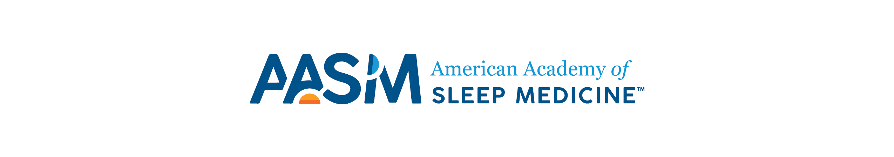
AASM Awards Nomination Application Form

Those interested in nominating an individual for the 2023 Nathaniel Kleitman Distinguished Service Award must complete the following form. The completed application form and the nominee’s CV must be submitted to awards@aasm.org by Nov. 27, 2022 for consideration by the AASM Awards Advisory Panel.

- Provide examples of how the nominee has demonstrated their commitment to the field of sleep medicine.

- Provide examples of the nominee’s contributions to the field of sleep medicine (e.g., original high-quality research, major publications, clinical practice, guidelines/chapters/course director positions, educational contributions, service on committees/task forces, fellowship development).

- Describe the impact of the nominee’s contributions on the field of sleep medicine.

- Please provide examples of the nominee’s commitment to the AASM (i.e., volunteering, leadership roles, speaking at AASM events).

- Provide examples of how the nominee embodies the values of AASM (Adaptable, Diverse and Inclusive, Evidence-based, Innovative, Patient-centered, Visionary).

