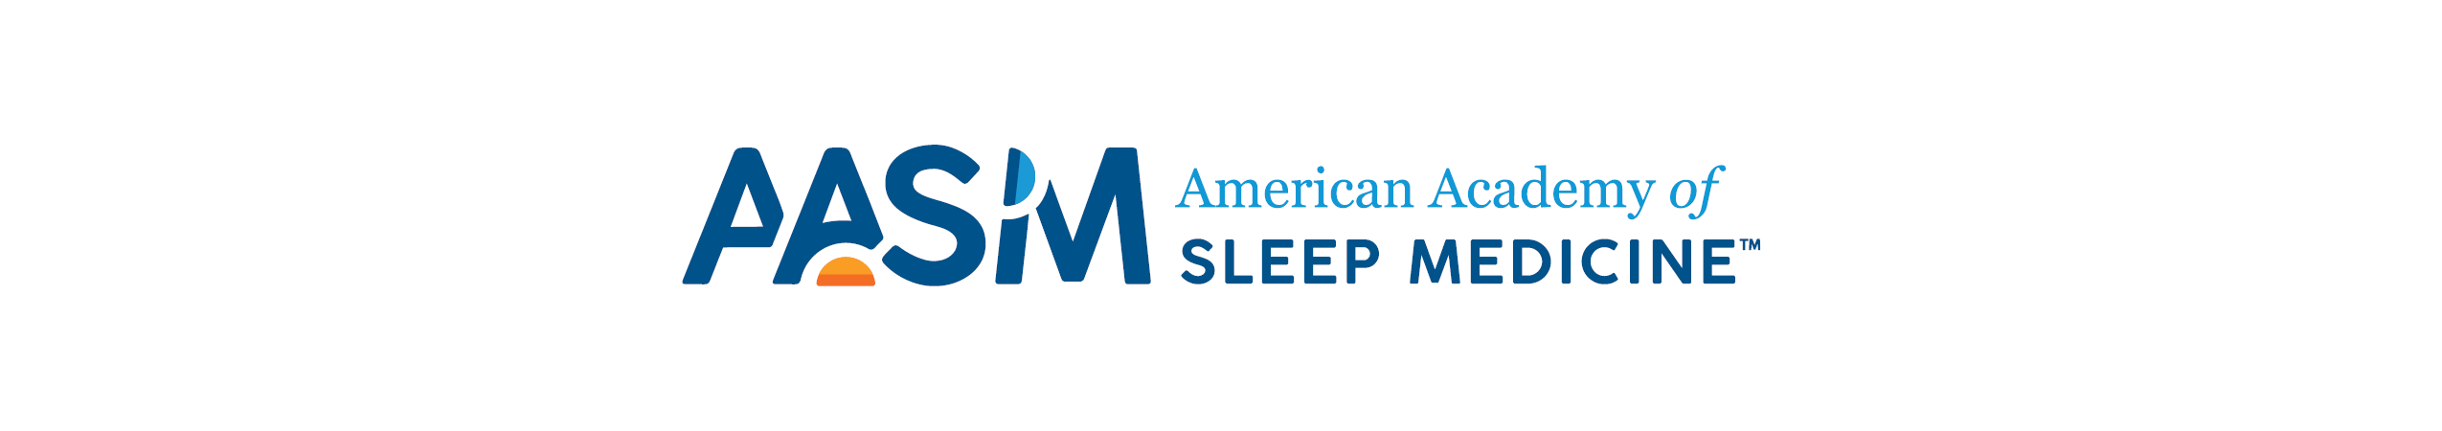
AASM Awards Nomination Application Form

Those interested in nominating an individual for the 2023 Mark O. Hatfield Public Policy or Advocacy Award must complete the following form. The completed application form must be submitted to awards@aasm.org by Nov. 27, 2022 for consideration by the AASM Awards Advisory Panel.

- Provide examples of significant initiatives to enhance public awareness of healthy sleep or prevent sleep deprivation that the nominee has developed or publicized.

- Please explain how the nominee’s service promises to improve patient or public welfare in a significant and lasting manner in the area of sleep medicine.

- Provide examples of how the nominee embodies the values of AASM (Adaptable, Diverse and Inclusive, Evidence-based, Innovative, Patient-centered, Visionary).

