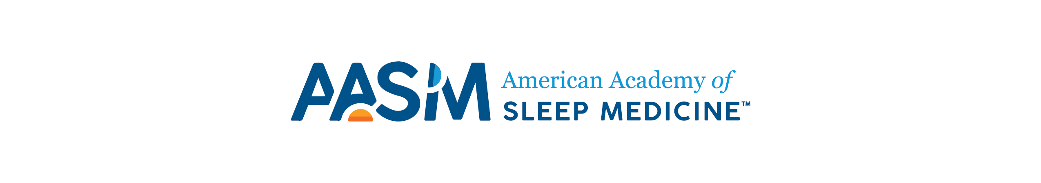
AASM Awards Nomination Application Form

Those interested in nominating an individual for the 2023 Excellence in Education Award must complete the following form. The completed application form and the nominee’s CV must be submitted to awards@aasm.org by Nov. 27, 2022 for consideration by the AASM Awards Advisory Panel.

- Provide examples of the nominee’s significant contributions to clinical, research or public education in the field of sleep and/or sleep medicine.

- Provide examples of the nominee’s impact on training and/or mentorship in the field of sleep medicine (e.g., experience as a mentor, development of training and/or certification programs).

- Please provide examples of the nominee’s commitment to the AASM (i.e., volunteering, leadership roles, speaking at AASM events).

- Provide examples of how the nominee embodies the values of AASM (Adaptable, Diverse and Inclusive, Evidence-based, Innovative, Patient-centered, Visionary).

