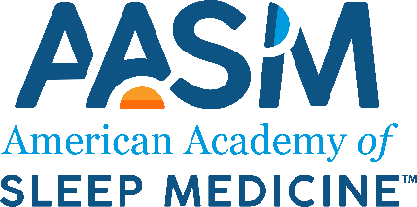
State and Regional Sleep Society COVID-19 Relief Fund Application

Instructions
To apply for AASM COVID-19 relief funding, you must be a U.S.-based, 501(c)3, 501(c)4, or 501(c)6 tax-exempt state or regional sleep society. Please complete the application, attach the required documentation, and submit the materials by sending an email to states@aasm.org.

Contact Information
Name of sleep society: Click or tap here to enter text.
Contact name: Click or tap here to enter text.
Contact title/role: Click or tap here to enter text.
Address: Click or tap here to enter text.
Email: Click or tap here to enter text.
Telephone: Click or tap here to enter text.
Website: Click or tap here to enter text.

Organization Profile
Number of members: Click or tap here to enter text.
Year established: Click or tap here to enter text.
Tax designation: ☐501(c)3 ☐501(c)4 ☐501(c)6
Briefly describe your organization’s mission and activities (maximum of 1 paragraph):
Click or tap here to enter text.

Required Documents
Check this box to indicate that your most recent financial statement (preferably an audited statement) is attached: ☐
Check this box to indicate that confirmation of your most recent state filing (e.g., annual registration) is attached: ☐
Check this box to indicate that confirmation of your most recent federal filing (e.g., Form 990/990-N) is attached: ☐

COVID-19 Impact
Amount of relief funding requested (maximum of $10,000): Click or tap here to enter text.
Describe the impact of COVID-19 on your operations and budget (maximum of 1 page):
Click or tap here to enter text.
Explain how relief funding will be utilized. Include a budget and justification (maximum of 1 page):
Click or tap here to enter text.

